**Lab Goal:** The Goal of this lab is to teach the user how to use more complex methods to solve a very basic problem.

**Lab Description:**  In this lab the user will have/create 4 jeroos. Each jeroo will try to get the flower out of the middle of the nets. When they are successful, they will put all the flowers in a square in the center of the screen.

|  |
| --- |
| **Files Needed:**  netFlower.jsc  netFlower.jev |

**Starting Screen:**

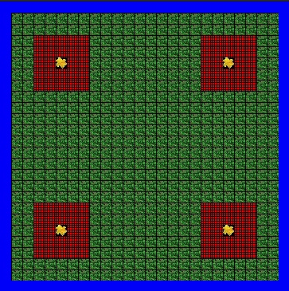

**Ending Screen:**

